**SET D- PART B**

**1. The value of the DS register is 3032H. And the BX register contains a 16-bit value which is equal to 3032H. 0008H is added to BX.  
ADD BX, 0008H  
The register AX contains some value that needs to be stored at a location as follows:  
MOV [BX], AX  
Calculate the address at which the value of the AX will be stored.**

After executing the first instruction, the value of BX Register is as follows:  
**BX = 3040H**

The BX register is an offset of the Data Segment (DS) register.

So, the location at which the value of the AX register will be stored is calculated as follows:

(DS X 10H) + BX

= 3032H X 10H +3040H

= 30320H + 3040H

= 33360H

**2. Find the type of addressing mode for the following instructions.**

## i) MOV AX, [BX] - Register indirect addressing mode

ii) ADD (A), R0 – Indirect addressing mode

## iii) MOV AX, [SI +05] – Base indexed addressing mode

**3. Compare and contrast auto-increment and auto-decrement addressing modes with an example.**

**Auto increment :**

A special case of Register Indirect Addressing Mode where

Effective Address of the Operand

= Content of Register

In this addressing mode,

* After accessing the operand, the content of the register is automatically incremented by step size ‘d’.
* Step size ‘d’ depends on the size of operand accessed.
* Only one reference to memory is required to fetch the operand.

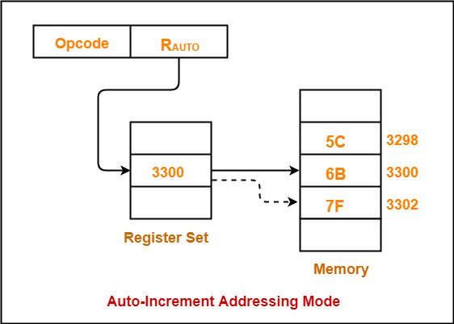

**Auto Decrement:**

* A special case of Register Indirect Addressing Mode where

Effective Address of the Operand

= Content of Register – Step Size

In this addressing mode

* First, the content of the register is decremented by step size ‘d’.
* Step size ‘d’ depends on the size of operand accessed.
* After decrementing, the operand is read.
* Only one reference to memory is required to fetch the operand.

